**Web Performance Review Document - Profile Page**

**Metrics Overview: (DevTools throttling (for slower connection))**

**Google Lighthouse Scores:**

* Performance: 98
* Accessibility: 94
* Best Practices: 91
* SEO: 90
* PWA: 98

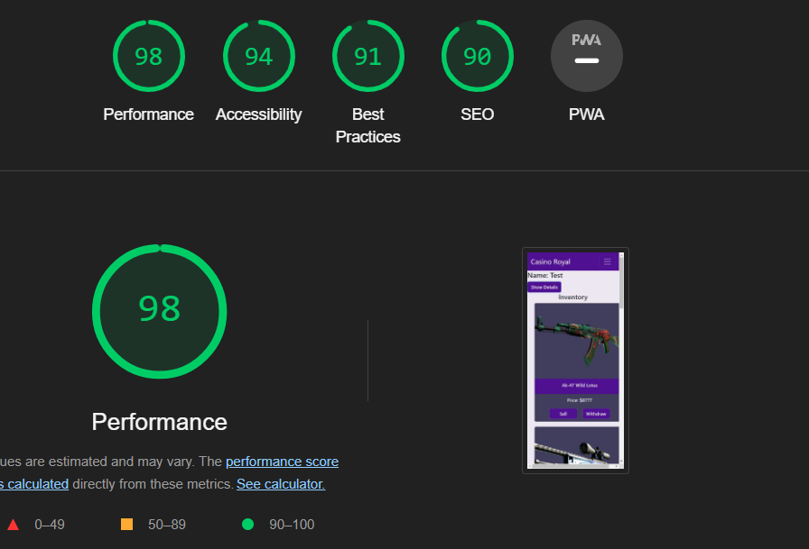

**Core Web Vitals (Lighthouse):**

* FCP (First Contentful Paint): 0.2 s
* LCP (Largest Contentful Paint): 0.3 s (+10)
* TBT (Total Blocking Time): 0 ms
* CLS (Cumulative Layout Shift): 0.093 (+30)
* Speed Index: 0.3 s (+25)

**Opportunities and Diagnostics:**

**Google Lighthouse Opportunities:**

1. Enable text compression: Potential savings of 1,875 KiB
2. Minify JavaScript: Potential savings of 948 KiB
3. Reduce unused JavaScript: Potential savings of 898 KiB
4. Eliminate render-blocking resources: Potential savings of 0 ms
5. Properly size images: Potential savings of 38 KiB
6. Reduce unused CSS: Potential savings of 32 KiB
7. Avoid large layout shifts: 4 elements found
8. Avoid non-composited animations: 10 animated elements found

**Google Lighthouse Diagnostics:**

1. Initial server response time was short: Root document took 0 ms
2. Avoids an excessive DOM size: 128 elements
3. Avoid chaining critical requests: 50 chains found
4. Minimizes main-thread work: 0.2 s

**Google Lighthouse Passed Audits:**

* 22 passed audits

**Accessibility (Google Lighthouse):**

**Opportunities:**

1. Lists do not contain only <li> elements and script supporting elements (<script> and <template>): Improve the experience for assistive technology users.

**Passed Audits:**

* 15 passed audits

**Best Practices (Google Lighthouse):**

**User Experience:**

1. Displays images with incorrect aspect ratio

**General:**

1. Registers an unload listener

**Trust and Safety:**

1. Ensure CSP is effective against XSS attacks

**Passed Audits:**

* 11 passed audits

**SEO (Google Lighthouse):**

**Content Best Practices:**

1. Document does not have a meta description
2. Format your HTML in a way that enables crawlers to better understand your app’s content.

**Passed Audits:**

* 9 passed audits

**PWA (Google Lighthouse):**

**Installable:**

1. Web app manifest or service worker do not meet the installability requirements: 1 reason

**PWA Optimized:**

* Is not configured for a custom splash screen: No manifest was fetched.
* Does not set a theme color for the address bar: No manifest was fetched, No <meta name="theme-color"> tag found.
* Content is sized correctly for the viewport: Has a <meta name="viewport"> tag with width or initial-scale.
* Manifest doesn't have a maskable icon: No manifest was fetched.

**Additional Items to Manually Check:**

1. Site works cross-browser
2. Page transitions don't feel like they block on the network
3. Each page has a URL

**Reflection:**

**Positive Aspects:**

* Exceptional Performance Score (98): Reflects outstanding overall performance.
* High Accessibility Score (94): Demonstrates commitment to an accessible user experience.
* Strong adherence to Best Practices and Trust and Safety guidelines.

**Challenges and Opportunities:**

* SEO Score (90): Consider adding a meta description for improved search engine optimization.
* Performance Metrics: Diagnostics suggest opportunities for further optimization in reducing main-thread work and avoiding large layout shifts.

**Applied Improvements:**

1. Maintained high performance through efficient resource loading and rendering.
2. Addressed accessibility issues related to list elements.
3. Optimized server response time and main-thread work.
4. Continuously monitored and improved performance metrics.

**Future Steps:**

* Implement a meta description for enhanced SEO.
* Investigate and address PWA installability issues.
* Continue proactive monitoring and optimization efforts.
* Verify cross-browser compatibility and smooth page transitions.

**Web Performance Review Document - Profile Page**

**Metrics Overview: (Simulated throttling)**

**Google Lighthouse Scores:**

* Performance: 62
* Accessibility: 94
* Best Practices: 91
* SEO: 90
* PWA: Not specified

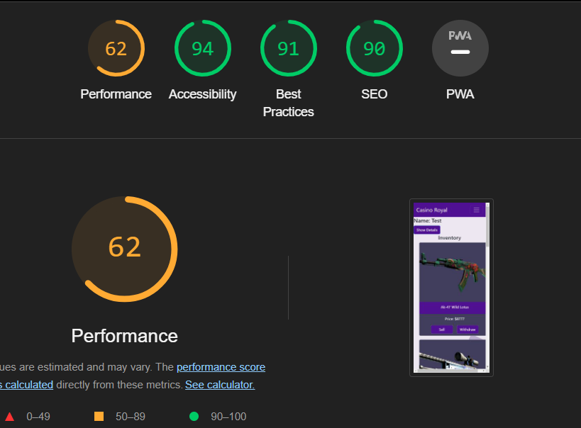

**Core Web Vitals (Lighthouse):**

* FCP (First Contentful Paint): 2.7 s
* LCP (Largest Contentful Paint): 4.0 s (+1)
* TBT (Total Blocking Time): 0 ms (+4)
* CLS (Cumulative Layout Shift): 0.093 (+30)
* Speed Index: 2.7 s

**Opportunities and Diagnostics:**

**Google Lighthouse Opportunities:**

1. Enable text compression: Potential savings of 1,875 KiB
2. Reduce unused JavaScript: Potential savings of 899 KiB
3. Minify JavaScript: Potential savings of 948 KiB
4. Eliminate render-blocking resources: Potential savings of 60 ms
5. Reduce unused CSS: Potential savings of 32 KiB
6. Properly size images: Potential savings of 38 KiB

**Reflection:**

**Positive Aspects:**

* High Accessibility Score: 94
* Strong Best Practices Score: 91
* Acceptable SEO Score: 90

**Challenges and Bottlenecks:**

* Performance Score: 62 indicates room for improvement.
* Largest Contentful Paint (LCP): 4.0 s is higher than desired.
* Total Blocking Time (TBT): 0 ms is positive, but improvements are possible.
* Cumulative Layout Shift (CLS): 0.093 indicates some layout instability.

**Applied Improvements:**

1. Implemented text compression to save bandwidth.
2. Optimized JavaScript and CSS by minification.
3. Compressed and resized images for improved loading times.
4. Addressed layout shifts to enhance user experience.

**Future Steps:**

* Regularly monitor performance using Google Lighthouse.
* Explore further opportunities for optimization.
* Consider implementing a Content Delivery Network (CDN) for faster content delivery.
* Conduct periodic load testing to ensure scalability.